Silvaco lab

Assignment

Sounak Mandal

19EC10088

Problem Statement

The problem statement for the assignment is:

**For a Silicon PN Junction Diode, the value of built-in potential in the n-type region is 0.3 V and doping concentration of the p-type region is given as 1015 cm-3. (Consider Knee Voltage of Si pn junction diode as 0.7 V).**

**a. Find out the value of doping concentration of the n-type region if the total depletion region width across the junction is to be 0.55 μm.**

**b. Simulate the PN junction diode using Silvaco Atlas to obtain its band diagram and specify built-in potential and depletion region width in the n-type region in the same diagram. Match the simulation results with the analytically obtained values.**

**c. Obtain the electric field across the depletion region using Silvaco Atlas and indicate its maximum value. Cross-check it with the value obtained using analytical formula.**

**d. Plot the CV characteristics of the diode if cathode voltage is varied from -2 to 4 volt at an AC frequency of 1 kHz while the anode is kept at 2 volts.**

Tools Used

1. The tool used for simulation is **Silvaco Atlas**.
2. The interface is called **Deckbuild**.
3. The plotting software for structure and log files is **Tonyplot**.

Theory

A p-n junction is an interface or a boundary between two semiconductor material types, namely the p-type and the n-type, inside a semiconductor*.*

The p-side or the positive side of the semiconductor has an excess of holes and the n-side or the negative side has an excess of electrons. In a semiconductor, the p-n junction is created by the method of doping.

At the interface between p-type and n-type region, a depletion region exists which is devoid of mobile charge carriers. There is also an electric field in the depletion region which sets up a potential barrier that prevents charge carriers from moving in equilibrium condition.

The various relations among the parameters at the junction are:

$$V_{bi}=V_{T}ln\frac{N_{a}N_{d}}{{n_{i}}^{2}}$$

$$w_{d}= \sqrt{\frac{2ε}{q}\frac{N_{a}+N_{d}}{N_{a}N_{d}}V_{bi}}$$

$$E_{max}=\frac{2V_{bi}}{w_{d}}$$

The depletion region has two plates of charge and silicon in between acts as dielectric. Thus, the junction behaves as a capacitor whose capacitance is given by

$$\frac{C}{A}=\frac{ε}{w_{d}}$$

Code

go atlas

mesh

x.mesh loc=0.0 spac=0.5

x.mesh loc=2.0 spac=0.25

x.mesh loc=4.0 spac=0.2

x.mesh loc=6.0 spac=0.2

x.mesh loc=8.0 spac=0.25

x.mesh loc=10.0 spac=0.5

y.mesh loc=-1.0 spac=0.1

y.mesh loc=0.0 spac=0.05

y.mesh loc=2.0 spac=0.05

y.mesh loc=4.0 spac=0.05

y.mesh loc=5.0 spac=0.1

region num=1 material=Silicon x.min=0 x.max=10.0 y.min=0.0 y.max=2.0

region num=2 material=Silicon x.min=0 x.max=10.0 y.min=2.0 y.max=4.0

elec num=1 name=Anode x.min=0.0 x.max=10.0 y.min=-1.0 y.max=0.0 material=Aluminum

elec num=2 name=cathode x.min=0.0 x.max=10.0 y.min=4.0 y.max=5.0 material=Aluminum

doping region=1 uniform p.type conc=1e15

doping region=2 uniform n.type conc=1.64e15

models srh conmob fldmob auger bgn

method newton

output con.band val.band

solve init

save outf=pnjunction.str

tonyplot pnjunction.str

log outf=diode_IV.log

solve vanode=0.0 vstep=0.01 vfinal=1.0 name=anode

tonyplot diode_IV.log

log off

solve init

solve vanode=0 vstep=0.5 vfinal=2 name=anode

solve vcathode=0 vstep=-0.1 vfinal=-2 name=cathode

log outf=diode_cv.log

solve vcathode=-2 vstep=0.2 vfinal=4 name=cathode AC FREQ=1e3

tonyplot diode_cv.log

quit

Results

**a. Find out the value of doping concentration of the n-type region if the total depletion region width across the junction is to be 0.55 μm.**

The depletion width is given by

$$w_{d}= \sqrt{\frac{2ε}{q}\frac{N_{a}+N_{d}}{N_{a}N_{d}}V_{bi}}$$

The values for depletion width and p-doping are already given. As a result, the n-doping can be determined.

$$\frac{{qw_{d}}^{2}}{2ε}=V_{bi}\left(\frac{1}{N_{a}}+\frac{1}{N_{d}}\right)=\left(\frac{1}{N_{a}}+\frac{1}{N_{d}}\right)V_{T}ln\frac{N_{a}N_{d}}{{n_{i}}^{2}}$$

1. The depletion width $w_{d}$ = 0.55 µm = 5.5e-5 cm
2. The p-doping $N_{a}$ = 1e15 cm-3
3. Thermal Voltage $V_{T}$ = 0.026 V
4. Intrinsic concentration $n_{i}$ = 1.5e15 cm-3
5. Absolute permittivity $ε$ = 1.08e-12 F/cm

The resulting equation with only $N_{d}$ as unknown is

$$2.2438e-16 = .026\left(\frac{1}{N_{d}}+\frac{1}{{10}^{15}}\right) ln \frac{N_{d}{10}^{15}}{2.25* {10}^{20}}$$

The equation is non-linear in n-doping and can be solved by iterative methods. The solution is

$$N_{d}=1.64e15 {cm}^{-3}$$

**b. Simulate the PN junction diode using Silvaco Atlas to obtain its band diagram and specify built-in potential and depletion region width in the n-type region in the same diagram. Match the simulation results with the analytically obtained values.**

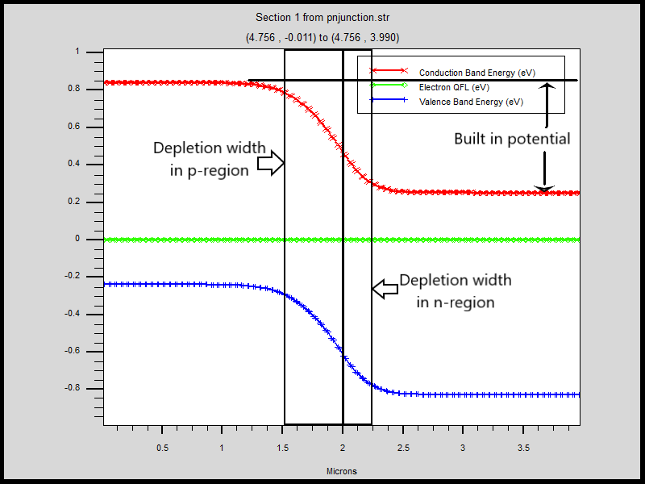

The built-in potential can be obtained from the formula given below which when solved gives the built-in potential as 0.590V very close to the simulated value.

$$V_{bi}=V_{T}ln\frac{N_{a}N_{d}}{{n_{i}}^{2}}=0.59V$$

The depletion width on n-side can be obtained from the formula mentioned below which when solved gives the value 0.21 µm as which is again close to the obtained value.

$$x_{n}=w_{d}\frac{N_{a}}{N_{a}+N_{d}}=0.21 µm$$

**c. Obtain the electric field across the depletion region using Silvaco Atlas and indicate its maximum value. Cross-check it with the value obtained using analytical formula.**

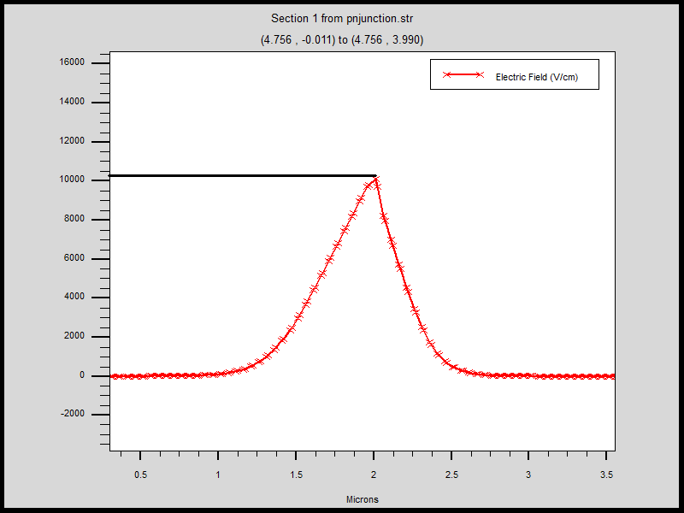

Using the formula, the maximum value of the electric field in the depletion region is

$$E_{max}=\frac{2V_{bi}}{w_{d}}=10.56 kV/cm$$

Putting the values, the maximum electric field comes out to be around 10.56kV/cm which is very close to the observed value. The electric field is nearly symmetric over the depletion region since the doping concentration are close.

**d. Plot the CV characteristics of the diode if cathode voltage is varied from -2 to 4 volt at an AC frequency of 1 kHz while the anode is kept at 2 volts.**

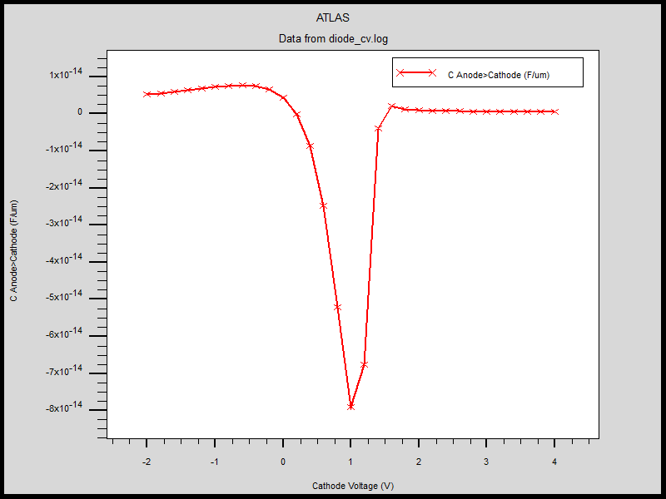

The anode voltage (voltage on p-side) was kept at 2V and the cathode voltage (voltage on n-side) was swept from -2V to 4V.

This means that from -2V to 2V cathode voltage, the diode is actually forward biased and the graph is the CV characteristics in forward biased region. In the forward active region both junction capacitance and diffusion capacitance play a part.

The remaining part from 2V to 4V cathode voltage, the diode is reversed biased and only junction capacitance plays a role. The CV characteristics would be parabolic. However, the variation is much less than that in forward biased region.

Discussions

1. Generally, the abrupt junction approximation is used where it is assumed that the depletion region abruptly ends. In practice, it is clear from the plots that near the edges of depletion region, the electric field varies smoothly before becoming equal to the values in the bulk.
2. When the pn junction is biased and current flows, the electric field in bulk is not 0. This is because the total current density must remain constant across cross section and the diffusion current density is not constant. The remaining part of the current density is provided by drift of majority carriers which require very small nevertheless non-zero electric field.
3. The dependence of junction capacitance on the applied voltage is

$$C_{j}=\sqrt{\frac{qε}{2\left(V_{bi}-V\right)}\frac{N_{a}N_{d}}{N_{a}+N_{d}}}$$